Trust as a Determinant of European Trade

David Matthews

**Abstract**

**Introduction**

Although trade has been nearly completely liberalized in the European over the last decade, there is still a considerable and poorly understood home bias within European countries, intra-continental trade in Europe is not where it would be if trade were perfectly efficient. Obviously, some amount of trade should remain local (Obstfeld and Rogoff, 2000), partially due to physical distance between countries, but the geography of countries does not fully explain this home bias. While many authors have analyzed the extent of home biases, this paper will focus more on determinants of home bias, addressing the theory that trust, both nationalized trust and bilateral trust, is a significant determinant in trade. Other explanations include transaction costs, asymmetric information, or exchange rate volatility, but I will take the cultural approach in looking at exchange disparities. This paper will address multiple types of trust, including country-specific and bilateral measures of trust, and analyze its impact on bilateral trade statistics, foreign direct investment, total trade as a percent of GDP, and GDP per capita. Bilateral trade numbers provide the most direct measure of a country’s international openness, but foreign direct investment, which is usually made by more educated and analytic mutual fund managers and other investment professionals, may show the impact of trust on financial exchange even amidst a highly erudite, professional group of people. This paper is organized into five further chapters. Chapter 2 shows the prior work in this field, which shows a few differing conclusions and headlined by Guiso, Sapienza, and Zingales’ work, “Cultural Biases in Economic Exchange.” Chapter 3 describes the data used in this project, which combines various questions from the World Values Survey and Eurobarometer, as well as OECD economic data, using a set of Python scripts. Chapter four focuses on the methodology to run my series of regressions in Stata, starting with OLS regressions and progressively becoming more complex with controls and instrumental variables. Following the regression techniques, chapter five will discuss the results and give theoretical justification for them. Finally, chapter six will summarize the results and determine if trust actually has a causal impact on trade, as well as giving possibilities for future research.

**Chapter 2: Related Research**

The primary work which inspired me to write this paper was Guiso, Sapienza, and Zingales’ work “Cultural Biases in Economic Exchange” (GSZ 2008), which discusses extensively trust and its effects on trade. I have decided to take another look on this subject for a variety of reasons. First, its data is old. Most of their financial data comes from 1996 or prior, and all of their trust data comes from 1996. In revisiting this subject, much has changed in the structure, openness, and perceptions of countries within Europe. Unfortunately, data for bilateral trust is still limited to the 1996 World Values Survey that GSZ used, but current survey data on intra-country trust levels has a relatively high correlation with the 1996 values. As such, I’ll use both in my analyses as a robustness check. Furthermore, trade statistics have likely changed dramatically since 1996. Europe has become more liberalized in terms of trade, more integrated in terms of geo-political issues, and more harmonized with the advent of the Euro. I believe that, as a result, current trade levels will greatly differ from those before the current level of European integration. Finally, I think 2013 data will be highly representative of “standard” economic conditions, as it is post-crisis and a moderate way through the recovery—neither too bullish or too bearish, but a healthy medium that should be representative of average economic conditions. Other work includes…

**Chapter 3: Data**

Data has consistently been difficult to find. The key question for running this analysis—“How likely are you to trust someone from country x”—is no longer present in the Eurobarometer and has not been present since 1996. Since then, there have been no good measures of bilateral trust between individuals of certain countries. This data probably is still representative of Europe, but, unfortunately, it is missing many country specific values. As a more modern proxy for trust, I’ve taken various questions referencing “trust” from the 2009 World Values Survey, including: “would you say that most people can be trusted or that you need to be very careful in dealing with people,” “how much do you trust your family,” “how much do you trust your neighborhood,” “how much do you trust people you know personally,” and “how much do you trust people of another nationality.” Because of data sparseness, I choose to use these measures in addition to the bilateral trust data. I believe that these will show dramatically different results than the bilateral trust data—in fact, I think that all of the questions except “how much do you trust people of another nationality” will have strongly negative coefficients on trade, based on high levels of personal trust leading to low levels of generalized trust (Alesina and Giuliano 2013). Additionally, I used a 2006 Eurobarometer special report to measure the percent of Europeans in each country who spoke English well. This data will serve as a valuable control my data because I believe that rates of English speaking—indicative of a country’s educational attainment and general exposure to world business, as English is the de facto official language of business for worldwide commerce—will also have a strong correlation with trade.

For my economic data, I use GDP data from the World Bank and trade data, including FDI and exports and imports, from the OECD. Both of these sources should be highly accurate and not prone to errors. To properly merge and format this data, I’ve imported it into a Python script that parses it and formats it into a manner that’s easily used by Stata in my regressions. While any code is susceptible to errors, I am confident in my data-management skills and do not believe that coding this data in Python could adversely affect my results.

In addition to my Python data manipulation, I build matrices for distance between capital cities, common legal origin, and religious similarity. The decision to use capital cities instead of economic centers was twofold—in almost all cases, the capital city is the largest city in each European country, and capital cities always represent a political center if not an economic center. While being the largest city does not necessarily mean it is an economic center, e.g. Frankfurt or Munich compared to Berlin in Germany or Northern Italy versus Rome, but population size is a good proxy for economic output, and analyzing output between cities in comparison with population sizes is too tedious of a task for this paper. To create this joint distance system, I manually take distances for every combination of capital city in Europe and import them into my Python data frame. For common legal origin, I divide each country into one of four categories—English (Common Law), French, Scandinavian, or German—and give a country a dummy variable of 0 or 1 whether or not they share legal origin with another given country. Although some countries blend legal traditions, such as Italy mixing together some elements of both the Napoleonic Code and German Law, common legal origins, in theory, should increase trust between states. The last control variable, religious similarity, is definitively the most difficult to retrieve data on. Because of no preexisting data sets on it, I take the fraction of each country’s religious denomination—or at least the five or six biggest denominations—multiplying them by every other country’s percentage of the same denomination to create a similarity index for each religion and each country. I then add the results for every different religion in each bilateral country pair to create the similarity index. In essence, I take the product of the fraction of people in country x and country y who have religion z and then add across all religions z (which represent Catholicism, Protestantism, Judaism, Islam, Orthodox, no religion, and Buddhism). Also presumably, people with higher religious similarities will exhibit more trust for people, but should not have an impact on international trade, which is done mostly on the firm level.

I then output my final data frame as a CSV into Stata. The final output of data sends the total value of a country’s bilateral imports and exports, the trust measures listed above, which I normalized on a scale from zero to one, each country’s total gdp, trade as a percent of GDP, rate of citizens (reporter, partner, and the product of the two) proficient in English, net FDI—both raw and as a percent of GDP—portfolio equity net inflows, partner GDP, distance between capital cities, common law origins, and religious similarity.

Once in Stata, I have a few more data manipulations that I want to perform. I take the log of all of the stock variables—total exports and imports, GDP, total exports, total imports, and FDI. I think these variables are otherwise highly skewed and would give heteroskedastic results in the following regressions, so a log transformation gives them a stronger correlative power. Finally, because I currently only have bilateral trade data between countries, I group trade by country and generalize a country’s statistics. I do this for two reasons: first, I want to see if country-specific, not bilateral, trust information has any correlation with overall trade in a country, i.e. do people more trusting of foreign people in general have enough trust in other nationalities to tangibly impact trade. Theoretically, people more willing to trust other nationalities would be more inclined to engage in international trade and investment, but without reciprocal trust—the trust shown in the bilateral data—it may be difficult to establish these relations in a generalized manner. The second reason for creating a variable for trade in entire countries is to provide trade variables that can help me create a European gravity model, which can get rid of many exogeneity issues. As a result of this effort, this data should be about as pure as it can be, given how sparse and loosely formatted the surveys consistently are created.

**Chapter 4: Methodology**

Now that my data is in Stata, I start running regressions to either establish correlation—and if so, work towards finding causality—or to disprove the idea that trust has an impact on trade. To get a general grasp on the data, I first run a series of OLS regressions, starting at the most basic models:

LogTradesi(overall, imports, and exports) = αi + β1i*Trust(of all variations) + β2i*LogGDP +εi  **(Eq. 1)**

Tradei(%ofGDP) = αi + β1i*Trust(of all variations) +εi **(Eq. 2)**

This basic specification, run on the course of the trust variables and using various trade measures as the dependent variable, gives some general insight into what can be expected over the course of the data. However, this specification is greatly limited. It suffers from extensive omitted variable bias and is not representative of an actual chain of causality. Similarly, I run the same regressions against Net FDI and Net FDI as a % of GDP. I expect somewhat similar results as before, but the FDI measure is essentially a robustness check.

My first main updated specification regresses the same system as equation one, but it adds a selection of controls into the system in addition to the log of GDP: English rate, law origins, religious similarity, and log of distance. I believe that all of these are omitted variables that can capture determinants of trade better than trust and GDP alone. I believe that English rate can affect trade through two channels: directly by increasing education and lowering the cost of transactions—as English is the world language of business—and also through trust because understanding people is key to trusting them. I think that English rate primarily affects trade through the trust channel and less through education, which makes it an effective instrument later on, which I will discuss. Common origin of law should increase trade due to providing more trade guarantees, lowering transaction costs, and lowering levels of information asymmetry. Religious similarity at first glance seems as if it should not affect trade—why should common religion increase trade when secular firms control trade—yet I find that religion has a strong impact on trade. My theoretical guess for this apparent discrepancy is that religious commonality historically leads to similar institutions that make it easier to trade between countries. Finally, the log of distance obviously should be analyzed in flows of trade—trade decreases as distance between capital cities increases. The distance between capital cities also leads me to my next specification: the gravity model.

Gravity models are frequently used to models financial flows, immigration flows, and basically anything in economics that depends on distance. The specification for my gravity model starts off as the standard model with bilateral trust added as an additional regressor: 

If bilateral trust is still significant, I will add back my controls into the gravity model, but currently I will undergo the gravity model with three different bilateral dependent variables, total trade, imports, and exports. The gravity model captures both the size of the importing and exporting countries and adjusts for the log of distance between nations.

The final regression specification that I’ll run will be a two stage least squares estimate, both with the basic regressions and with the control vector of legal origin, and religious similarity added to it. Originally, I planned on using religious similarity as my instrument, as I assumed religious similarity to be exogenous to trade but highly correlated with trust. In testing the exogeneity of religious similarity, I found that it had a highly significant correlation with trade, even under a variety of controls. This effect is probably due to the institutions argument I proffered before, but it requires me to determine a new instrument. As such, I attempted to use reporting mutual English-speaking rates as an instrument in the hopes that English rates only affect trade through increasing trust. Unfortunately, it seems as if this instrument is also invalid, and, in fact, has a much higher impact on trade than bilateral trust, which indicates that trade increases more from the ability to speak the common language itself instead of the interpersonal trust. After my two instrument choices fail, I do not have any other instruments readily available, but this is not a huge issue, as instead of proving causality for my explanatory variable, trust, I truly believe that I am creating doubt upon the impact of bilateral trust on trade.

**Chapter 5: Results**

The standard OLS regressions, straight from the beginning, give some surprising results. First, the log of total trade regressed against the trust people have towards other people in general has a negative coefficient, but is only statistically significant at the 10% level, even controlling for the log of GDP. Given the principles of amoral familism, which stipulate that people trust people intimately close with them—family and neighbors, basically—the correlation between neighborly trust and trade makes sense, which is neighborhood trust is more negatively correlated with the log of trade and is significant at the 1% level when correcting for the log of GDP (Figure 1). This does not surprise me, as groups with stronger family ties are more isolated than those with weaker ties, and, in fact, it leads you to suspect that trust in family is even more strongly negatively correlated with the log of trade. When the same regression is done against trade as a percent of GDP (Figure 2), the sign remains the same, but neighborly trust loses significance. However, fittingly, family trust levels in both basic regressions are strongly negative and statistically significant at the 1% level. Similarly regressions between trade and trust between people “you know personally” show significant negative coefficients. All of these initial results point to indications that stronger bonds between close family and friends limit productivity and stifle international exchange. My first surprising, and quite interesting, result comes from the question, “How much do you trust people of another nationality.” At first glance, the intuitive thought is that this measure would increase trade, right? If someone trusts people from another nationality more, then that person should be more likely to trade with other nations, but the results don’t support this conclusion. Both regression results give strongly negative correlation to this question in relation to trade. Obviously, this is a simplistic regression, and there almost assuredly are omitted variables causing biases as well as extensively missing data due to the World Values Survey incompletely addressing nations, but I cannot think of any solid theoretical background as to why this might be the case. The only argument that is somewhat supported in the literature is that diverse countries generally have less economic growth than homogenous countries, and there may be some link there between trade growth as well (. Regardless, the last simplistic regression that I run is the log of total trade value against bilateral trust, and it gives me what I’m expecting—a statistically significant positive coefficient at the 5% level. This coefficient holds 5% significance against controls for the log of GDP, and the country’s English rate, indicating that some of the most obvious omitted variables do not affect its impact.

Next, I analyze the impact of the various trust measures on foreign direct investment in a similar manner. As we see in Figure 3, the results are substantially the same between trade in goods and flows of investment, albeit slightly lower in significance for the FDI statistics. This is precisely what I expected—FDI likely represents less information asymmetry with financial professionals focusing more on due diligence and breaking into unknown markets, as well as finance professionals generally being less risk-averse than business managers.

Moving on from simplistic regressions, I add a series of controls to my baseline ordinary least squares regression, including English rates, legal origin, religious similarities, and the log of distance. The first additional variable, the product of the English rates spoken by

**Conclusion**

In making sweeping claims about how trust may affect trade, one must exercise great caution in three things: what type of trust, what type of trade, and causality. Common border, a full language similarity index

**Bibliography**

Alesina, A. and P. Giuliano. 2014. “Family Ties.” In *Handbook of Economic Growth*, edited by Philippe Aghion and Steven N Durlauf, 2A:177-215. The Netherlands: North Holland.

Alesina, A. and E. La Ferrara (2005) "Ethnic Diversity and Economic Performance." *Journal of Economic Literature*, 43(3): 762-800.

Banfield, E., *The Moral Basis of a Backward Society*, (New York, NY: Free Press, 1958).

Easterly, W. and R. Levine (1997) “Africa’s Growth Tragedy: Policies and Ethnic Divisions,” *Quarterly Journal of Economics* 112 (4): 1203-1250.

Guiso, L., P. Sapienza, and L. Zingales, (2004) “*U*Cultural Biases in Economic Exchange*U*”, NBER Working Paper No. 11005.

Guiso, L., P. Sapienza and L. Zingales (2004),“*U*The Role of Social Capital in Financial Development*U*,” *American Economic Review,* Vol. 94, No. 3, 526-556.

Obstfeld, Maurice, and Kenneth Rogoff. "The Six Major Puzzles In International Macroeconomics: Is There A Common Cause?." *NBER/Macroeconomics Annual (MIT Press)* 15.1 (2000): 339-390. *Business Source Complete*. Web. 11 Dec. 2015.

**Appendix**

Figure 1:

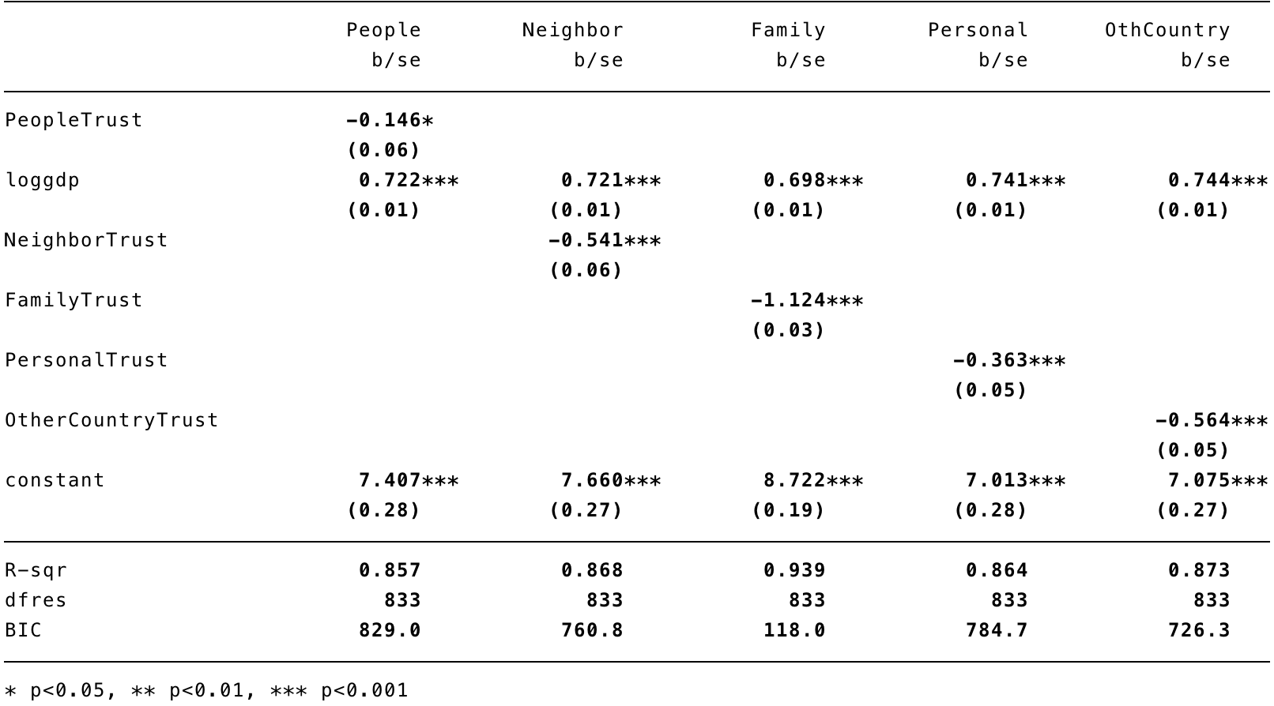

Figure 2:

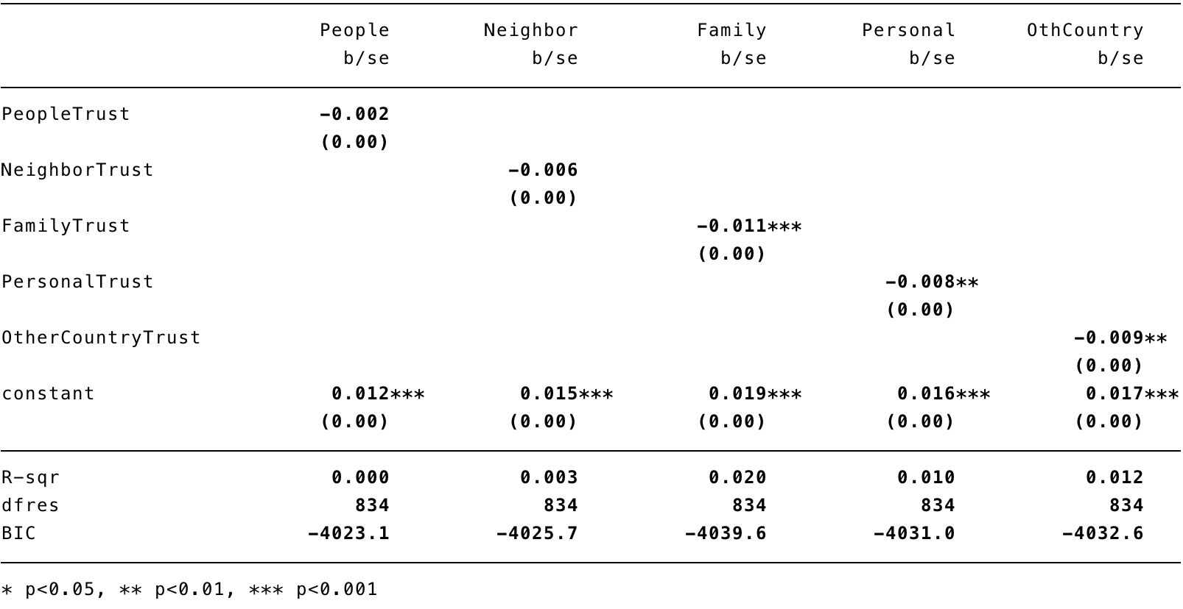

Figure 3:

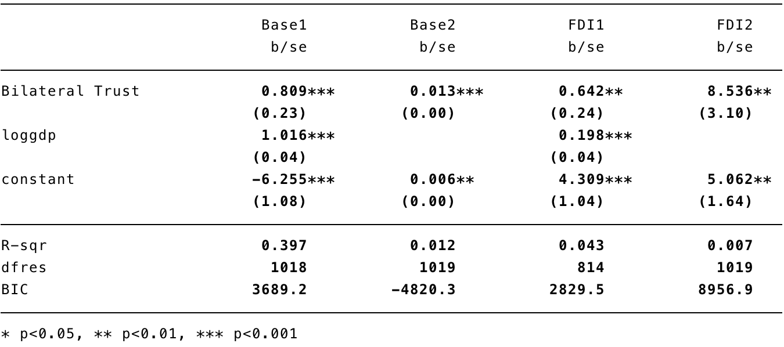

Figure 4:

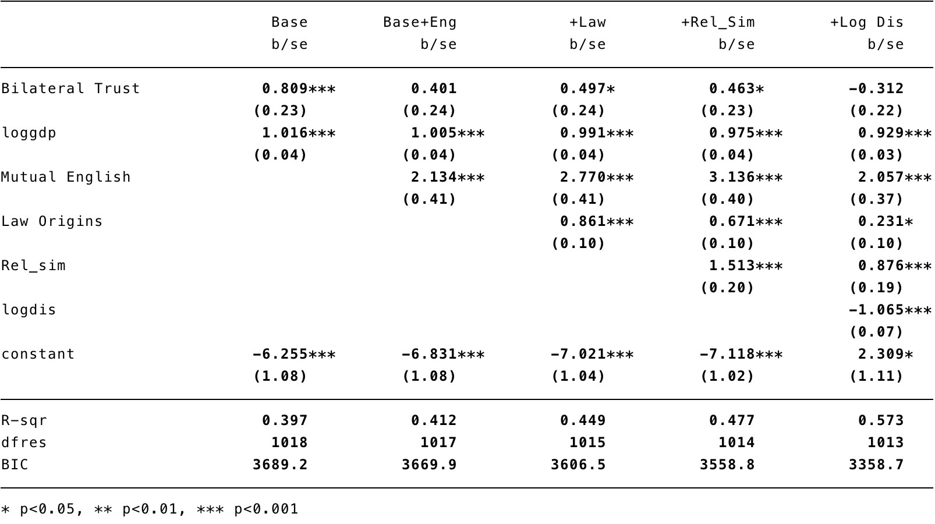

Figure 5:

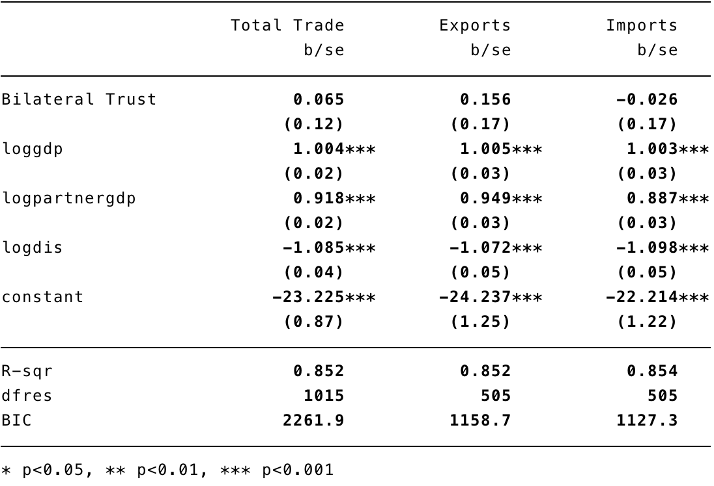

Figure 6:

